RESPONSE
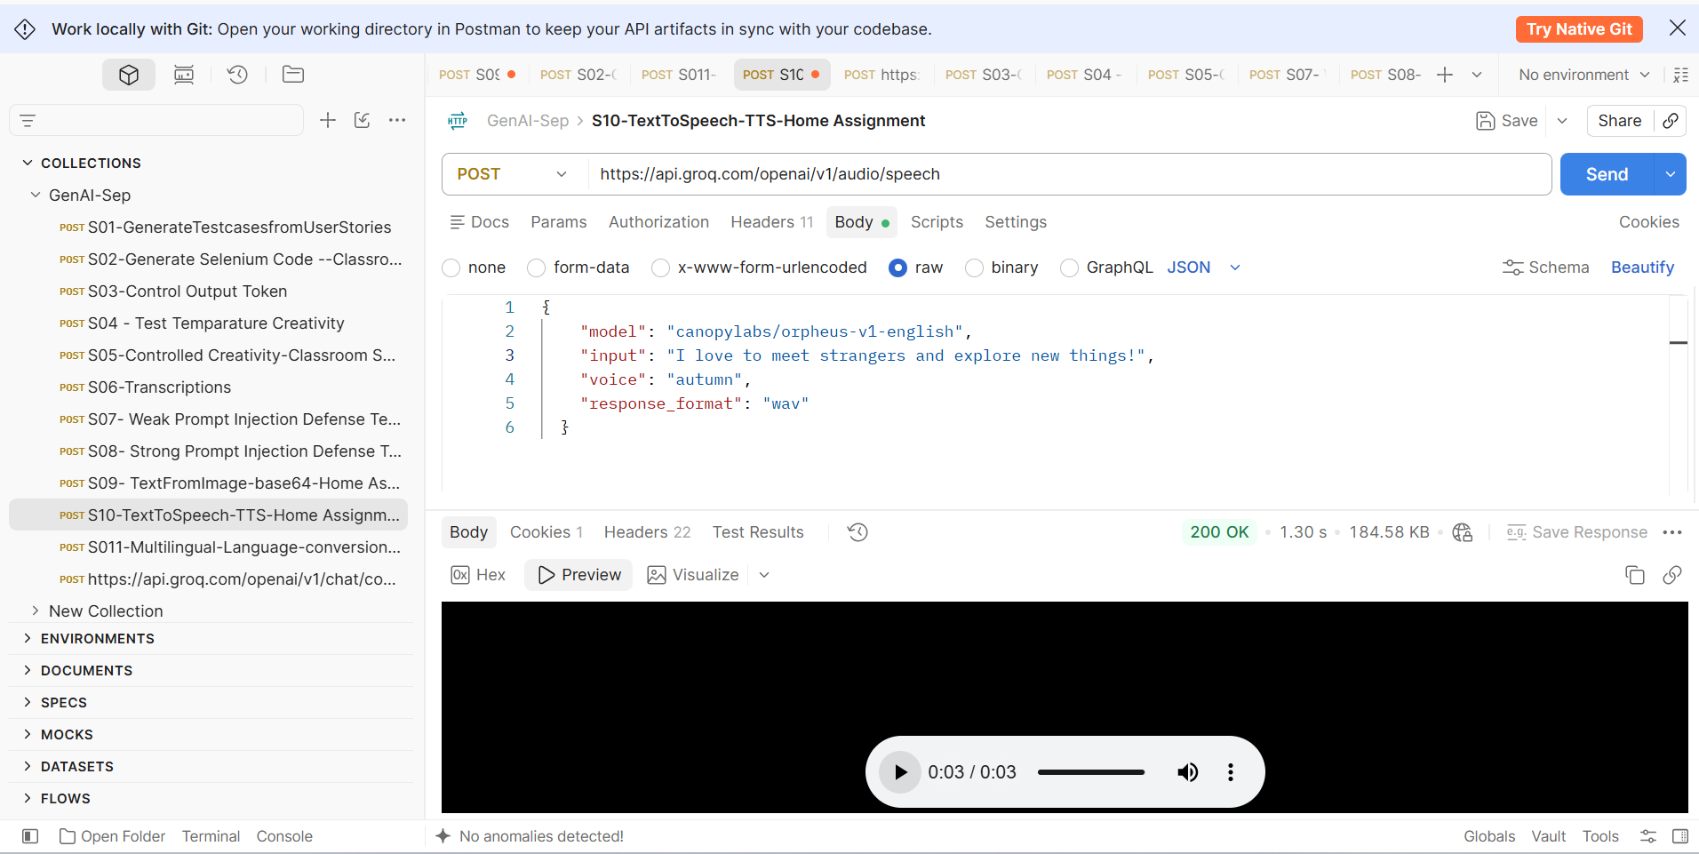

REQUEST
{
"model": "canopylabs/orpheus-v1-english",
"input": "I love to meet strangers and explore new things!",
"voice": "autumn",
"response_format": "wav"
}

